June 22, 2022

Dear Citizen,

Box Elder County has received a General Plan Amendment, text amendment to the Box Elder County General Plan to update the County Resource Management plan. Please be aware of an upcoming public hearing (notice is set forth below).

**NOTICE OF PUBLIC HEARING**

NOTICE IS HEREBY GIVEN that a public hearing has been scheduled on July 20, 2022 at 11:30 a.m. or as soon as possible thereafter, to receive public input regarding a General Plan Amendment. The public hearing will be held in the Commission Chambers at the Box Elder County Courthouse 1 S Main Street, Brigham City, Utah 84302. All interested parties are invited to attend.

Sincerely,

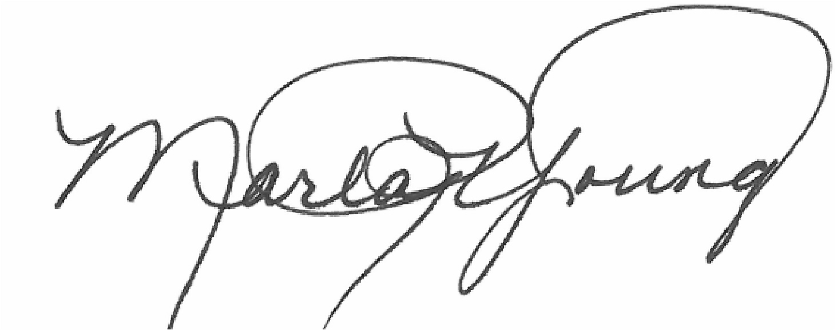

Marla R. Young

Box Elder County Clerk