2009 Box Elder Sheriff’s Office Annual Report

1-Sheriff’s Message
2-County Demographics
3-Organizational Chart
4-Mission Statement
5-Department Patch
6-Budget
7-Detectives

A-Strike Force

B-# of cases, arrests, quantity of drugs seized
8-Civil

C-Number of services (10 years)
9-Court
10-Patrol

D-Organization

E-# of cases by type, area, time of day

F- Citations and Warnings

G-CAR assignments

H-DARE, SWAT, K-9, Hostage Negotiations, DRE,

11-Corrections

I-# of bookings, inmate count

J-transport

K-medical

L-inmate services

M-Kitchen

N-Inmate worker programs
12-ITS
13-Communications
14-Emergency Management
15-Building and Grounds
16-Fire Marshall
17-Volunteers

O-Search and Rescue

P-Scuba

Q-Horse Posse

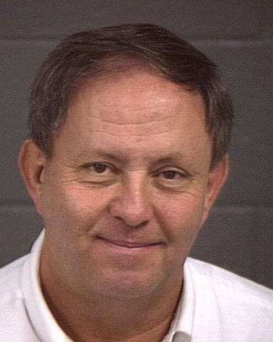

Message from Sheriff Yeates

Welcome. After 33 years working for the Sheriff’s Office, I was elected and took office in January 2007. I appreciate the opportunity the citizens have given me to serve them and it has been a pleasure to do so. The purposes of this annual report is explain to the citizens what changes have been made during the last year, provide crime statistics and explain the efforts on our part to serve the public.

My focus has been to create new or enhance existing partnerships with the citizens. Preparing this annual report is just one way of bettering the communication between the public and my office. I hope the information presented here answers questions and gives insight into our operations. After taking office, I informed my employees that nothing would be as important during my tenure as Sheriff as community relations. I truly believe this and continually reinforce this principle. For example, I instituted a program in which citizens that had contact with a deputy are contacted on a random basis and asked about their encounter. This lets the citizens know I am truly concerned about their interaction with the department and lets the deputies know I am holding them accountable.

All of the department functions are explained in this report. As you will see, our department provides a variety of services. About half of our budget goes to corrections and a fourth to patrol. The majority of the budgets are spent on personnel.

The size and terrain of Box Elder County makes it a particularly unique and wonderful place to live. These same attributes, plus a growing population, create challenges for the Sheriff’s Office. It will take great efforts for the Sheriff’s Office to keep pace with the changing nature of our county. It will be impossible to accomplish without a cooperative effort with our citizens.

Box Elder County Population* 2009 | 49,500
*estimated
**BESO Sworn Officers | 30
**Administration, Patrol, Investigations
# of Officers per 1000 population | 0.61

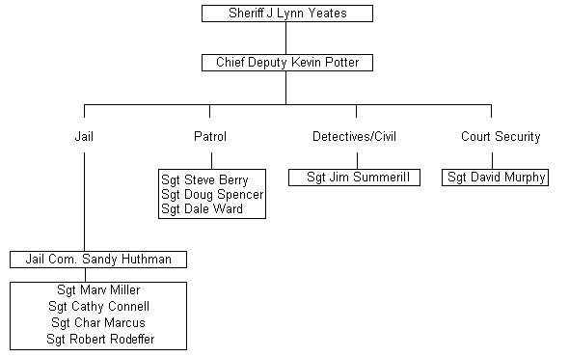

Direction and Guidelines for Sworn Officers

Sheriff J. L. Yeates - January 2007

Mission Statement
-Reduce crime and the fear of crime.
-Establish a solid partnership with the citizenry to create safe and secure communities.
-Provide a knowledgeable staff that ensures professional commitment to law enforcement, is focused and dedicated to the citizens and communities and uses imagination, innovation and resourcefulness.
-Provide high quality, cost effective, accountable services.
-Standards for law enforcement must include Fair Access, Public Trust, Safety and Security,
-Coordinated Team Work with officers and citizens and Community Involvement/Responsibility.

Nothing will be as important in my tenure as Sheriff as community relations. Most of the citizens of this county may have only one contact with an officer in their life. Their perception of our department and me personally comes from that contact. Contact with law enforcement is, for most people, a highly unusual event and is remembered for a long time. I expect every citizen who has contact with an officer to leave with the feeling they were dealt with by a competent, knowledgeable, well-trained professional who was polite and courteous. In addition, a citizen making a complaint should feel the officer did everything they could to solve the case or find a resolution. Most important is to follow up, even if that means nothing has developed in their case. If they need a question answered and you don't know, find out and call them back. If you refer them to another agency or department, give them a phone number and a contact name.

Law enforcement is a profession. Professions require schooling to achieve certification, continuing education requirements, specializations, decertification, etc. By definition, you are a professional. Take pride in your dress and appearance. Please represent yourself like a professional to the public and others in your profession.

Professionals train constantly. The 40 hours a year required by POST barely covers keeping your various certifications current. Find and request training in your weak areas. Become an expert or instructor in your strengths. Care about what is going on in law enforcement and keep up with current trends. I will support training that gives technical expertise and instructor status with the understanding that budget and benefit to the department are considerations. Expect to come back from training and teach what you learned to the department.

A law enforcement officer's authority and power to take away a citizens constitutional rights is unmatched anywhere in our society. Never, ever abuse this privilege or the position of trust you hold. Your word is your bond and should be in all your dealings.

In return, you can expect from me that I will support training, programs, equipment and a pay scale which represent professional policing. I understand that no one knows how to do a job better than the one doing it. I want your input and feedback, through your supervisor, on what’s being done right and what needs improvement.

I will follow the chain of command and expect you to do the same.

Department Patch

Green and Tan colors- represent Sheriff’s Colors and mountain and desert Surroundings.
1856- Year the Box Elder Sheriff’s Department was established.
Trains/Spike- Transcontinental railroad completed in our county

Marshland- Migratory Bird Refuge
Mountains- Represent the various mountain ranges in our county, some of which are almost 10,000 ft.
History, Agriculture and Industry- Three things that make Box Elder County famous and a great place to live.

Vehicles
We have implemented a vehicle purchasing program whereby all deputies will have 4 wheel drive vehicles. The size and terrain of our County require 4 wheel drive in many cases. In the past, deputies would have to switch vehicles to respond to calls in certain areas. We felt valuable time was wasted during this switch.

In an effort to save taxpayer money we have begun to purchase midsize 4-wheel drive vehicles which have a higher miles per gallon and a lower purchase price.

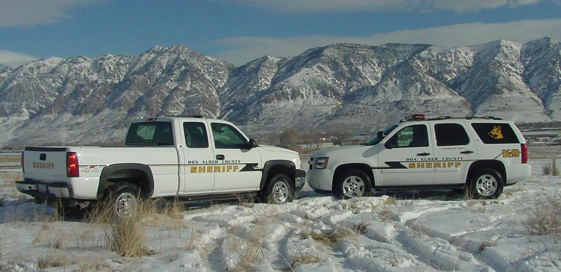

Uniforms
While the department colors haven’t changed, new hats, jackets, pants and other items have been approved.

Budget

Detective Division 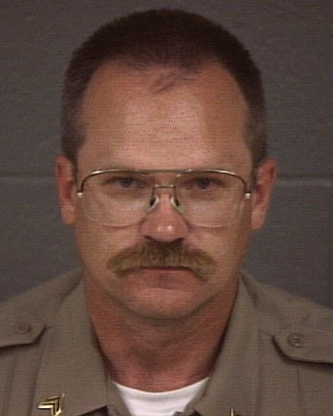
The detectives are supervised by Sgt. Jim Summerill. Sgt Summerill is also the field supervisor for the Narcotic Task Force and Civil division.

The detective division investigates major crimes committed in the county. There are four detectives, one of whom is assigned full time to the multi-jurisdictional narcotic task force. The other three detectives specialize in property crimes, sex crimes, fraud, death investigation, internal investigations, crime scenes and livestock theft. They also manage the evidence room.



Box Elder County Multi-Jurisdictional Narcotic Task Force (Strike Force)

The Sheriff’s Department participates in the Strike Force by assigning one full-time detective and a part-time field supervisor. Brigham Police also provide a full-time detective and part-time administrator. Tremonton Police provides a full-time detective. Most other jurisdictions provide some part-time help.
The Strike Force was set up to allow targeted, focused investigation on drug use and traffic in Box Elder County. The Strike Force operates with the assistance of federal grants. The Strike Force also gives presentations to work, social, school, and civic groups. If you would like a presentation, please call the Strike Force secretary at (435)734-3813

.

*Also seized were 1623 Rx pills with a HIDTA value of about $32,460.

Civil Division

The Sheriff is assigned by law to serve civil processes and execute court orders. There is a full-time deputy and full-time secretary assigned to this division. Often, the Patrol or Detective Division will assist in civil process serving to meet demand.

Court Division 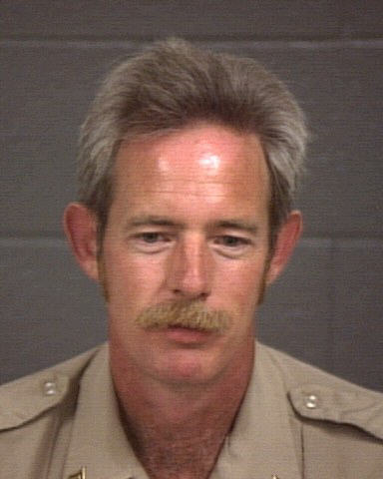

This division is supervised by Sgt. Dave Murphy.

The Sheriff is required, by law, to provide services to the District Court, Juvenile Court and Box Elder Justice Court. This includes Bailiff duties and building security.

A Bailiff of the court is tasked with the safety of the judge and court staff and to maintain order in the courtroom.

The Security aspect includes monitoring court buildings and areas through a control center, magnetometers and entry points and a uniformed presence.

Over 3,444 hours spent on Bailiff duties.

Over 6,750 hours spent on Security.
43,117 visitors to the 1st District Court House.

Patrol Division 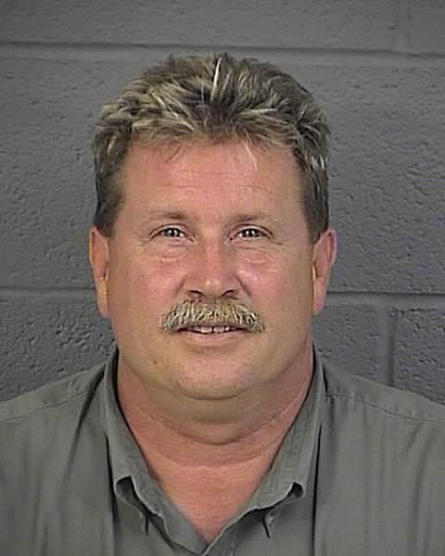 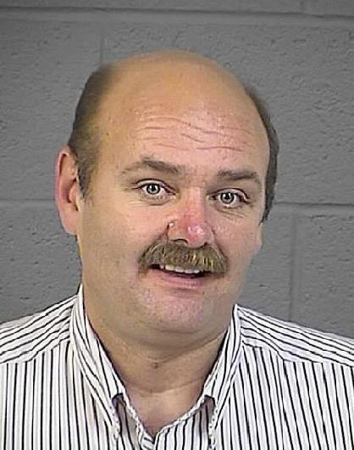 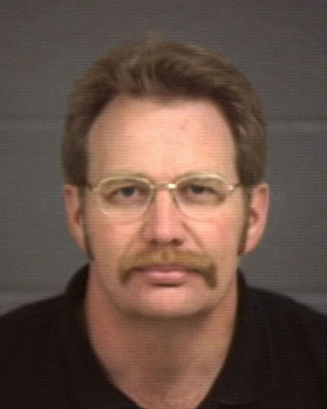
Berry Spencer Ward

The patrol division is supervised by Sgt. Steve Berry, Sgt Doug Spencer, and Sgt. Dale Ward. There are 16 deputies assigned to cover the county 24 hours a day. Due to the size of the county, deputies are assigned to cover patrol areas during their shifts. This includes the western part of the county.

Community Area Representatives –CAR
In additional to regular patrol duties, deputies are assigned a town or area in the county. They are expected to attend community meetings or functions and have an expertise in that community. To find out what deputy is assigned to your area, please call one of the patrol Sgts. (Sgt Steve Berry 435-734-3885, Sgt Doug Spencer 435-734-3807, Sgt Dale Ward 435-734-3805)

K-9
The K-9 division is now staffed by Deputy Brandon Yates and K-9 Kosmo and Deputy Kent Wiggins and K-9 Helix.

SWAT
Several deputies participate in a multi-agency, county-wide SWAT Team.

Hostage Negotiations
The county has two certified hostage negotiators. The certification required over three weeks of training and requires annual re-certifications

Drug Recognition Experts(DRE)
The county has 2 deputies certified as DRE. These deputies were trained to recognize the physical, clinical and neurological signs and systems associated with different kinds of drug use. DRE’s are an invaluable asset for drug related DUI’s and other crimes.

2009 Calls For Service by Nature
911 Unknown | 98 |  | Follow Up Inv | 4 |  | Security Check | 3
Abandoned Vehic | 31 |  | Forgery | 1 |  | Sex Offense | 23
Abdominal | 1 |  | Found Child | 1 |  | Sheriff Service | 11
Admin Assignment | 1 |  | Found Property | 11 |  | Shoplifter | 1
Agency Assist | 565 |  | Fraud | 55 |  | Sick Person | 13
Aggres Animal | 29 |  | Gas Leak | 1 |  | Simple Assault | 23
Alarm | 143 |  | Gas Skip | 20 |  | Slide Off | 23
Alcohol Offense | 27 |  | Harassment | 22 |  | SRT | 2
Allergy | 1 |  | HAZMAT | 4 |  | Stab/Gunshot | 6
Animal Bite | 17 |  | Health & Safety | 16 |  | Stalking | 5
Animal Carcass | 5 |  | Heart Problem | 2 |  | Stroke | 5
Animal Injury | 25 |  | Hemorrhage | 1 |  | Suicide Attempt | 3
Animal Problem | 146 |  | Hit & Run PD | 6 |  | Suicide Threat | 12
Assault / Sexua | 1 |  | Illegal Burning | 14 |  | Susp Person | 38
Asslt by Prsnr | 1 |  | Impound | 17 |  | Suspicious | 140
Attempt Locate | 14 |  | Indecent Expos | 3 |  | Suspicious Vehi | 52
Bad Check | 4 |  | Industrial Acc | 1 |  | SWAT | 5
Breathing | 20 |  | Injured Person | 1 |  | Tazer Deploy | 1
Burglary | 39 |  | Intoxication | 4 |  | Tel Harassment | 25
Burns | 1 |  | Juvenile Prob | 58 |  | Theft | 112
Business Licens | 3 |  | K9 Service | 76 |  | Theft Automobil | 5
Carbon Monoxide | 2 |  | Keep The Peace | 5 |  | Theft Vehicle | 1
Cardiac Arrest | 8 |  | Littering | 5 |  | Threatening | 33
Chest Pain | 8 |  | Livestock | 80 |  | Tip | 13
Child Abuse | 27 |  | Loitering | 3 |  | Tobacco Problem | 5
Choking | 2 |  | Lost Property | 10 |  | Traffic Enf | 9
Citizen Assist | 317 |  | Medical | 9 |  | Traffic Hazard | 80
Citizen Dispute | 44 |  | Mental Problem | 1 |  | Traffic Offense | 81
Civil Problem | 36 |  | Missing Juvenil | 7 |  | Traffic Problem | 2
CO Poisoning | 2 |  | Missing Person | 10 |  | Traffic Stop | 1
Convulsions | 13 |  | Motorist Assist | 47 |  | Transport Juven | 8
CRIM MISCHIEF | 1 |  | Noise Complaint | 37 |  | Transport Pris | 11
Curfew | 1 |  | Overdose | 11 |  | Traumatic Injur | 11
Custodial INT | 41 |  | Paper Process | 6 |  | Trespassing | 67
Death Invest | 10 |  | Parking Problem | 13 |  | Truancy | 1
Deliver Message | 1 |  | PD Accident | 125 |  | Unconsciousness | 17
DIABETIC PROB | 10 |  | PI Accident | 44 |  | Unknown Problem | 5
Diabetic Shock | 1 |  | Pornography | 2 |  | Unknown Trouble | 1
Disorderly | 18 |  | Probation Viol | 3 |  | Unsecure Premis | 67
Drug Rec Expt | 4 |  | Property Damage | 46 |  | Utility Problem | 3
Drugs | 22 |  | Prot Order Viol | 15 |  | Vagrancy | 2
DUI | 17 |  | Prowler | 3 |  | Vandalism | 48
Evading | 2 |  | Psychiatric | 7 |  | Vehicle Burg | 7
Explosives | 1 |  | Public Relation | 2 |  | Vehicle Fire | 7
Extra Patrol | 25 |  | Rape | 4 |  | Vehicle Lockout | 3
Eye Problems | 1 |  | Reckless Drivin | 20 |  | Vehicle Search | 1
Fall | 15 |  | Recovered Prop | 1 |  | VIN Inspection | 197
Family Fight | 65 |  | Recovered Veh | 1 |  | Wanted Person | 106
Fire | 42 |  | Road Debris | 4 |  | Weapon Offense | 42
Fire Alarm | 3 |  | Robbery | 1 |  | Welfare Check | 62
Fire Assist | 16 |  | Runaway Juvenil | 16 |  | Wildlife | 18
Fireworks | 4 |  | Safety Hazard | 6 |  | Wireless 911 NR | 2
Fix It Ticket | 15 |  | Search & Rescue | 4

Speed-Box

At the end of 2009 the Department purchased a devise that measures traffic at specific locations. The Speed-Box, as we like to call it, can be placed at about any location in the County to measure 4 traffic statistics; how many vehicles passed by, the time of day, their speed, and their direction of travel. From this data we see the true picture of each location’s traffic. This data helps Deputies know how best to conduct speed enforcement.

Corrections Division 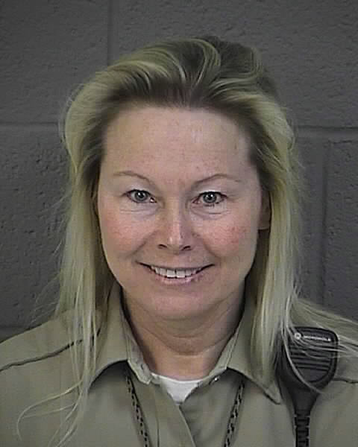

The Corrections division is supervised by Commander Sandy Huthman.

The Sheriff is required by law to maintain a county jail. Our facility has 168 inmate beds with twenty six of those beds reserved for females. There is a mix of Dormitory and Pod style with individual cell type housing. It requires a variety of assignments to maintain a correctional facility including:

Floor and control room officers
These officers ensure the security of the inmates and monitor the day to day activity.

Inmate services
These officers are responsible for commissary, billing and accounts.

Kitchen
Civilian cooks with inmate workers provide three meals a day.

Transport
These officers escort inmates to court appearances, medical appts., etc.

Medical
The jail contracts with a local doctor for medical services. The doctor visits inmates twice a week. There is one full-time and one part-time nurse to see to routine medical issues.

Work Crews
These officers take inmate workers to various areas in the county for cheap labor. Inmate crews have worked at the Landfill, courthouse, fairgrounds, food bank and for different municipalities. Inmate workers also staff the laundry, kitchen, warehouse and cleaning crews.
NEW Pay For Stay
Pursuant to Utah code 76-3-201(6) (May 29, 2009) The county jail is now charging inmates $10 a day for their incarceration. If the inmate can pay this bill within 30 days of his/her release then there is a 25% reduction.
NEW Day Reporting
In January of 2009 we began using the Day Reporting program. This new program is another option the Judge can use in lieu of jail time. In this program a person convicted of a crime could be sentenced to a number of days of Day Reporting. The convicted would report to the Day Reporting Officer and be subject to drug testing. The convicted would also pay $30 a month as well as the costs for the drug testing.

Programs

Inmates may take classes in the following areas:
Substance abuse, including Alcoholics Anonymous, Narcotics Anonymous, Power over Addiction and 12 step meetings.

Anger Management

GED

Parenting

Religious services

High School Diploma
Work Release- Some inmates are allowed to work their normal jobs and return to jail.
Day Reporting- Enables the Justice Courts to place a person on a day reporting program in lieu of jail time.

ITS 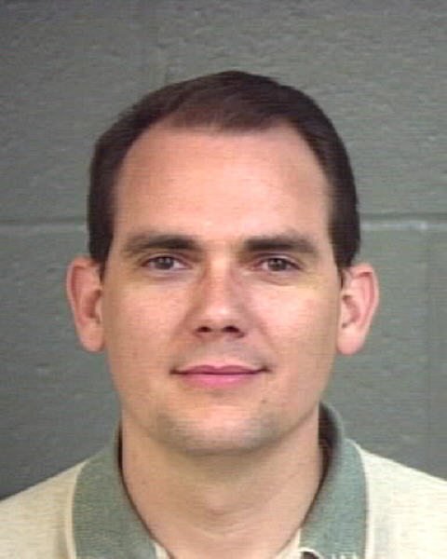
Corrections Officer Russell Roberts is responsible for the maintenance, repair, upgrades and replacement of computers, laptops and servers.

Communications

Box Elder Communications Center (BECC) is managed by the State of Utah.

Box Elder County and Brigham City used to run separate dispatch centers. Several years ago it was decided a combined dispatch would save tax dollars. The current dispatch center is funded by the state and local agencies combined. The employees are state employees. Box Elder funded dispatch at $784,436 in 2009.

Emergency Management
Emergency Management is the process of mitigating, planning, responding and recovering from natural diasters/terrorism/haz-mat. The Sheriff and Chief Deputy have this assignment.
Emergency Medical Services falls under Emergency Management. The Sheriff overseas 12 Emergency Medical technicians and two ambulances in Park Valley and Grouse Creek.

Buildings and Grounds
A full-time civilian employee is responsible for the care, repair, maintenance and upkeep at the jail, offices, line cabins and storage buildings.

Fire Marshall 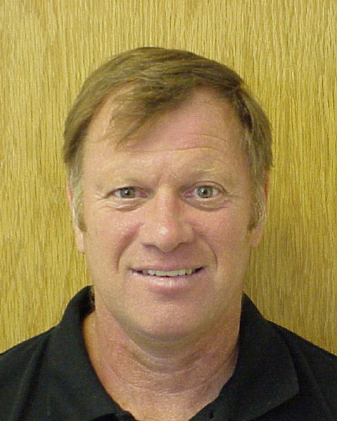

Greg Martz is the Box Elder County Fire Marshall.

Wildland fires in the un-incorporated areas of the county are a Sheriff responsibility by law. That’s why the Fire Marshall works out of the Sheriff’s Office. There is one full-time Fire Marshall and one part-time secretary. Several part-time marshals are hired during fire season. Contracts with local fire departments give the county the manpower needed to fight Wildland fires. There is state and federal reimbursement for fighting fires on their property.

2009
Fires responded to | 53
Acres burned | 679

Volunteer Organizations

Box Elder Sheriff Search and Rescue
With about 40 members, this all volunteer group will leave their “real” jobs at a moments notice to conduct rescue or recovery operations. They are equipped with 4 wheel drives, ATV’s, snowmobiles, snow-cat, light plant truck and a command center. They conduct twelve to fifteen operations per year. They also provide security at the County Fair and Peach Days

Box Elder Sheriff Scuba Team
This all volunteer group specializes in water rescue and recovery. 20 members are certified rescue divers and 20 are support staff. They are equipped with a pontoon boat, zodiac, 2 airboats and a command center. They assist at the county fair and operate on funds raised by selling the famous “Scuba Burger” at Peach Days

Box Elder Sheriff’s Horse Posse
The 100 person volunteer group is available for searches and also dazzles crowds at the county fair with a horsemanship display. They also assist at the county fair and on searches.

