2012 Box Elder Sheriff’s Office Annual Report

2-Sheriff’s Message
4-County Demographics
4-Organizational Chart
5-Mission Statement
7-Department Patch
8-Uniforms/Vehicles
9-Budget
10-Detectives

Strike Force

# of cases, arrests, quantity of drugs seized
12-Civil

Number of services (10 years)
13-Court
14-Patrol

CAR, K-9, DARE, SWAT, DRE

17- # of Calls For Service

18- Citations and Warnings

Speed-Box
21-Corrections

Personnel assignments

Inmate worker programs

# of bookings, inmate count
25-ITS
25-Communications
25-Emergency Management
25-Building and Grounds
26-Fire Marshall
27-Volunteers

Search and Rescue

Scuba

Horse Posse

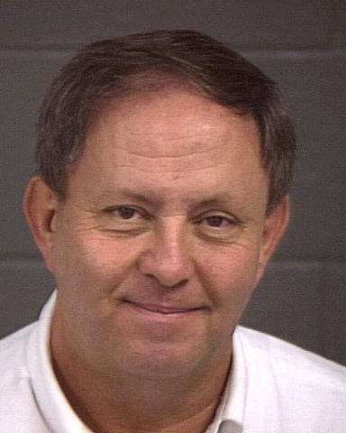

Message from Sheriff Yeates

Welcome. After 33 years working for the Sheriff’s Office, I was elected and took office in January 2007. In November 2010, I was re-elected for another four year term. I appreciate the opportunity the citizens have given me to serve them and it has been a pleasure to do so. The purpose of this annual report is to explain to the citizens what changes have been made during the last year, provide crime statistics and explain the efforts on our part to serve the public.

My focus has been to create new or enhance existing partnerships with the citizens. Preparing this annual report is just one way of bettering the communication between the public and my office. I hope the information presented here answers questions and gives insight into our operations. After taking office, I informed my employees that nothing would be as important during my tenure as Sheriff as community relations. I truly believe this and continually reinforce this principle. For example, I instituted a program in which citizens that had contact with a deputy are surveyed on a random basis and asked about their encounter. This lets the citizens know I am truly concerned about their interaction with the department and lets the deputies know I am holding them accountable.

All of the department functions are explained in this report. As you will see, our department provides a variety of services. About half of our budget goes to corrections and a fourth to patrol. The majority of the budgets are spent on personnel.

The size and terrain of Box Elder County makes it a particularly unique and wonderful place to live. These same attributes, plus a growing population, create challenges for the Sheriff’s Office. It will take great efforts by the Sheriff’s Office to keep pace with the changing nature of our county. It will be impossible to accomplish without a cooperative effort with our citizens.

Box Elder County Population 2012 | 50,290
BESO Area of Assigned Responsibility | 15,104
Estimated based on estimated County growth
BESO Sworn Officers | 28
Administration, Patrol, Investigations
# of Officers per 1000 population | 1.85

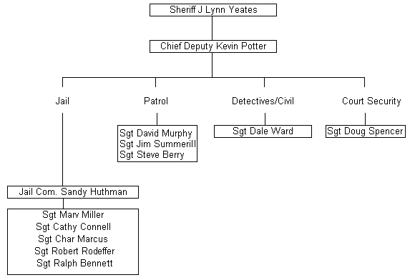

Direction and Guidelines for Sworn Officers

Sheriff J. L. Yeates - January 2011

Mission Statement
-Reduce crime and the fear of crime.
-Establish a solid partnership with the citizenry to create safe and secure communities.
-Provide a knowledgeable staff that ensures professional commitment to law enforcement, is focused and dedicated to the citizens and communities and uses imagination, innovation and resourcefulness.
-Provide high quality, cost effective, accountable services.
-Standards for law enforcement must include Fair Access, Public Trust, Safety and Security,
-Coordinated Team Work with officers and citizens and Community Involvement/Responsibility.

Nothing will be as important in my tenure as Sheriff as community relations. Most of the citizens of this county may have only one contact with an officer in their life. Their perception of our department and me personally comes from that contact. Contact with law enforcement is, for most people, a highly unusual event and is remembered for a long time. I expect every citizen who has contact with an officer to leave with the feeling they were dealt with by a competent, knowledgeable, well-trained professional who was polite and courteous. In addition, a citizen making a complaint should feel the officer did everything they could to solve the case or find a resolution. Most important is to follow up, even if that means nothing has developed in their case. If they need a question answered and you don't know, find out and call them back. If you refer them to another agency or department, give them a phone number and a contact name.

Law enforcement is a profession. Professions require schooling to achieve certification, continuing education requirements, specializations, decertification, etc. By definition, you are a professional. Take pride in your dress and appearance. Please represent yourself like a professional to the public and others in your profession.

Professionals train constantly. The 40 hours a year required by POST barely covers keeping your various certifications current. Find and request training in your weak areas. Become an expert or instructor in your strengths. Care about what is going on in law enforcement and keep up with current trends. I will support training that gives technical expertise and instructor status with the understanding that budget and benefit to the department are considerations. Expect to come back from training and teach what you learned to the department.

A law enforcement officer's authority and power to take away a citizen’s constitutional rights is unmatched anywhere in our society. Never, ever abuse this privilege or the position of trust you hold. Your word is your bond and should be in all your dealings.

In return, you can expect from me that I will support training, programs, equipment and a pay scale which represent professional policing. I understand that no one knows how to do a job better than the one doing it. I want your input and feedback, through your supervisor, on what’s being done right and what needs improvement.

I will follow the chain of command and expect you to do the same.

Department Patch

Green and Tan colors- represent Sheriff’s Colors and mountain and desert surroundings.
1856- Year the Box Elder Sheriff’s Department was established.
Trains/Spike- Transcontinental railroad completed in our county

Marshland- Migratory Bird Refuge
Mountains- Represent the various mountain ranges in our county, some of which are almost 10,000 ft.
History, Agriculture and Industry- Three things that make Box Elder County famous and a great place to live in.

Uniforms
While the department colors haven’t changed, new hats, jackets, pants and other items have been approved.

Vehicles
We have a fleet management program whereby all deputies will have 4 wheel drive vehicles. The size and terrain of our County require 4 wheel drive in many cases. In the past, deputies would have to switch vehicles to respond to calls in certain areas. We felt valuable time was wasted during this switch.

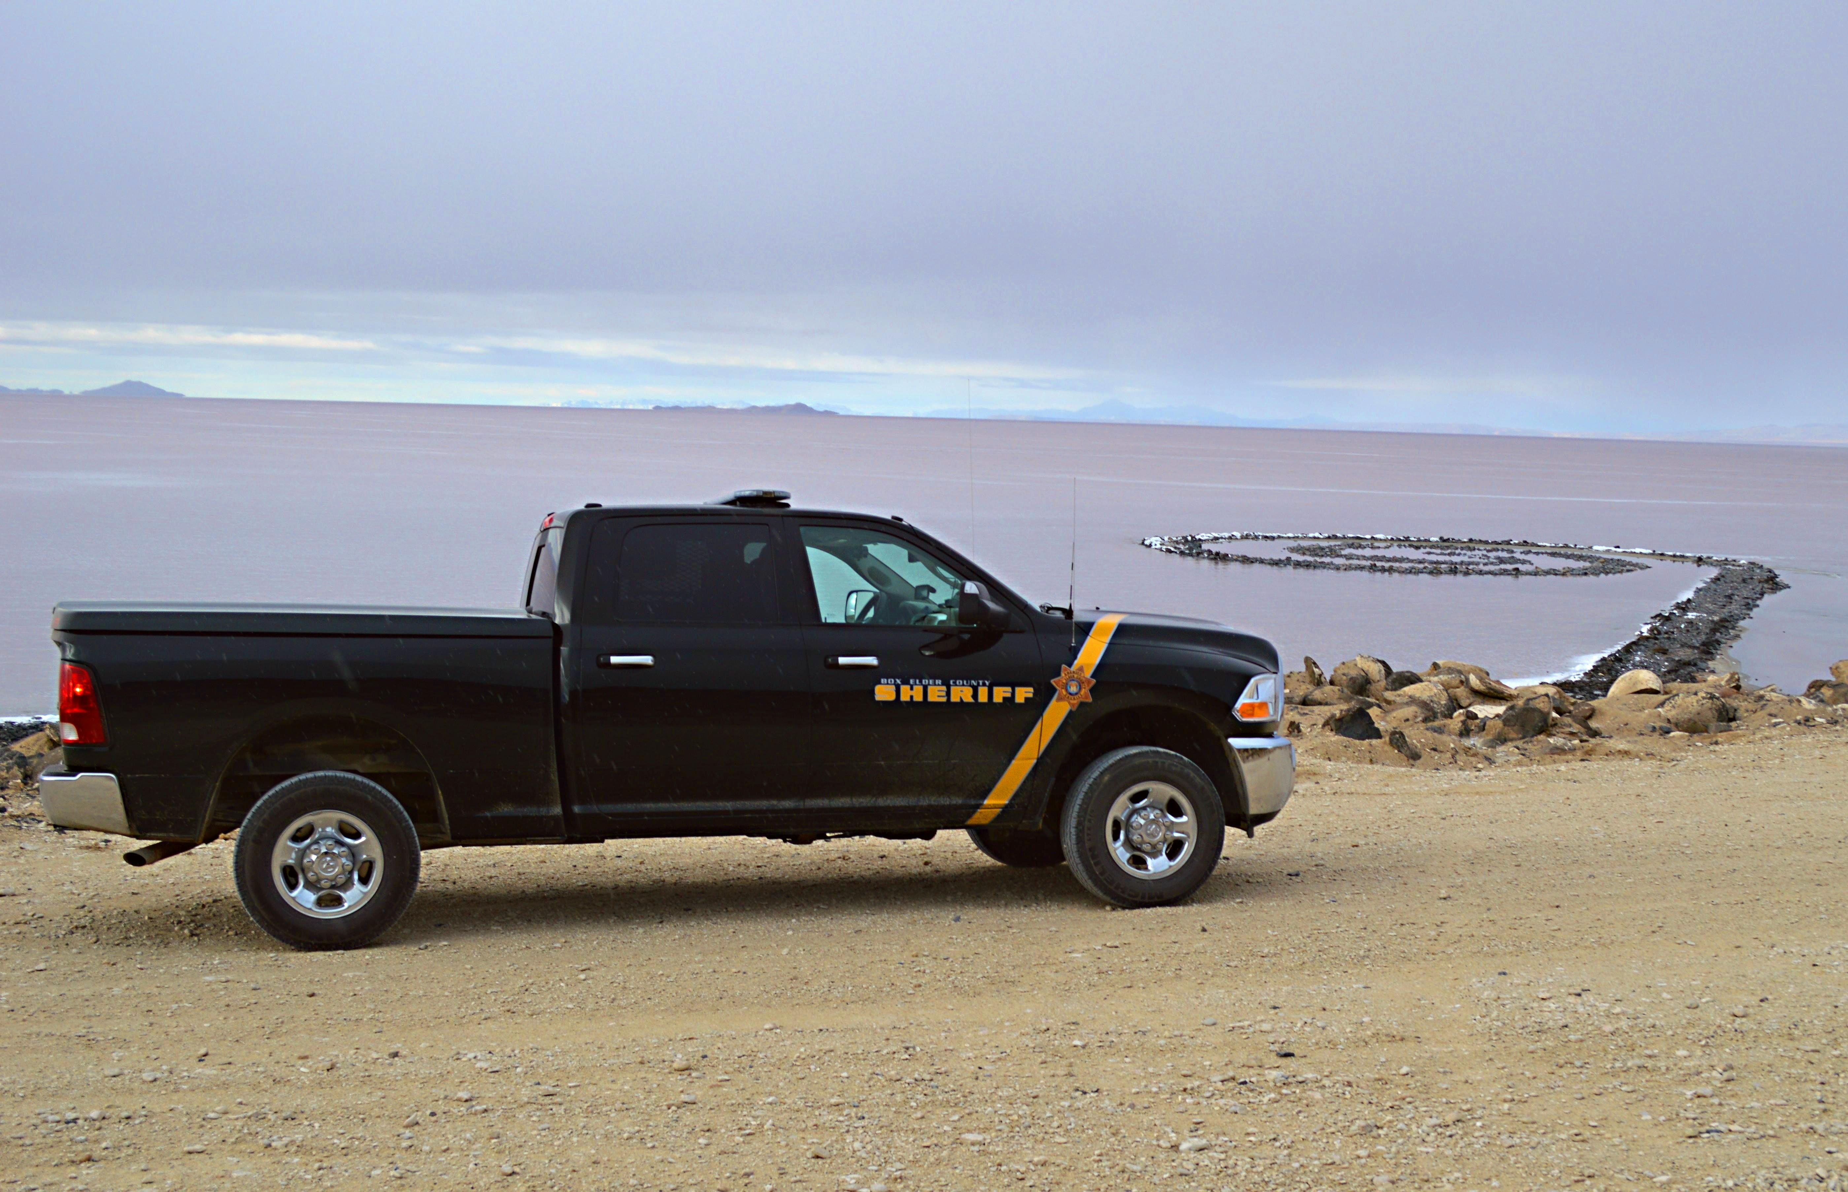

Budget
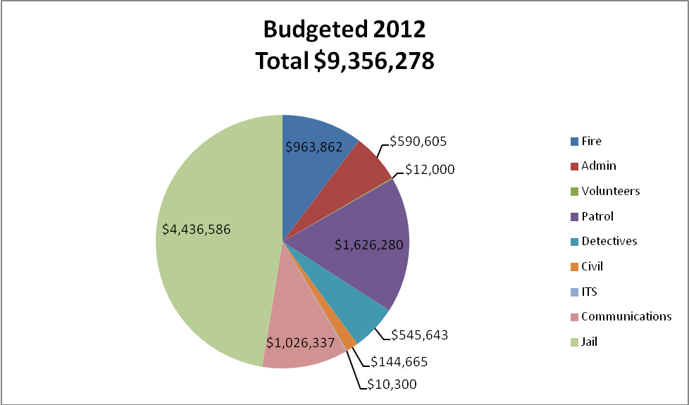
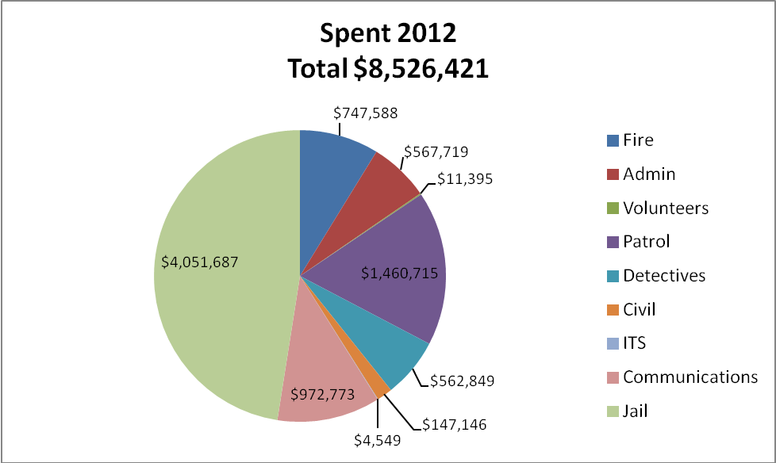

Detective Division 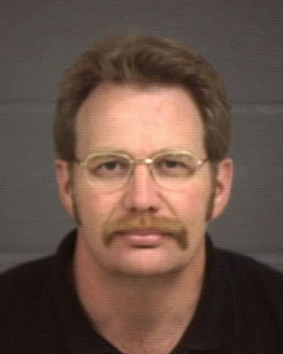
The detectives are supervised by Sgt. Dale Ward. Sgt Ward is also the field supervisor for the Narcotic Task Force as well as the Sheriff Civil division.

The detective division investigates major crimes committed in the county. There are four detectives, one of whom is assigned full time to the multi-jurisdictional narcotic task force. The other three detectives specialize in property crimes, sex crimes, fraud, death investigation, internal investigations, and crime scenes. They also manage the evidence room.



Box Elder County Multi-Jurisdictional Narcotic Task Force (Strike Force)

The Sheriff’s Department participates in the Strike Force by assigning one full-time detective and a part-time field supervisor. Brigham Police also provide a full-time detective and part-time administrator. Tremonton Police provides a full-time detective. Most other jurisdictions provide some part-time help.
The Strike Force was set up to allow targeted, focused investigation on drug use and traffic in Box Elder County. The Strike Force operates with the assistance of federal grants. The Strike Force also gives presentations to work, social, school, and civic groups. If you would like a presentation, please call the Strike Force secretary at (435)734-6490

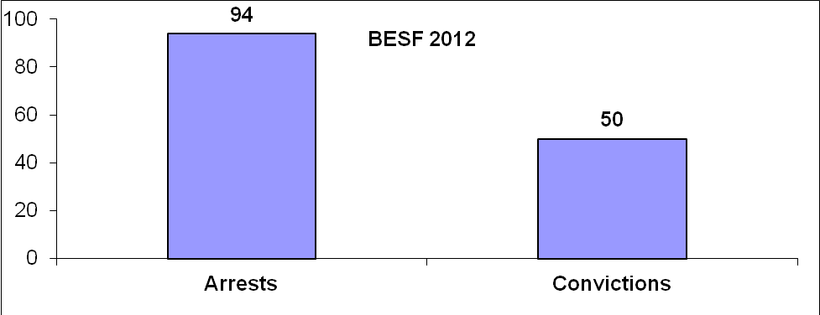

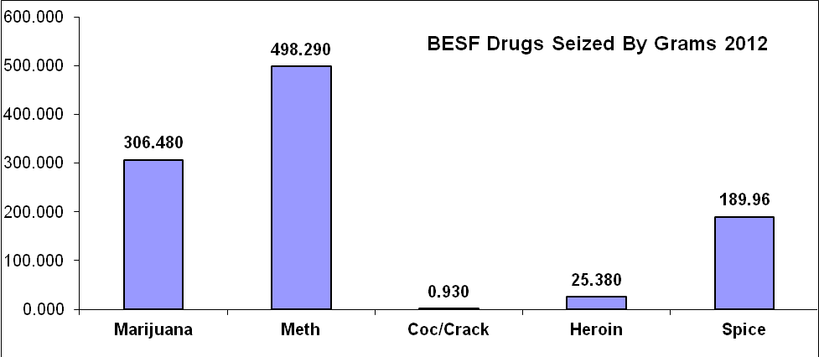
*Also seized were 583 Rx Pills Valued at about $11,660.

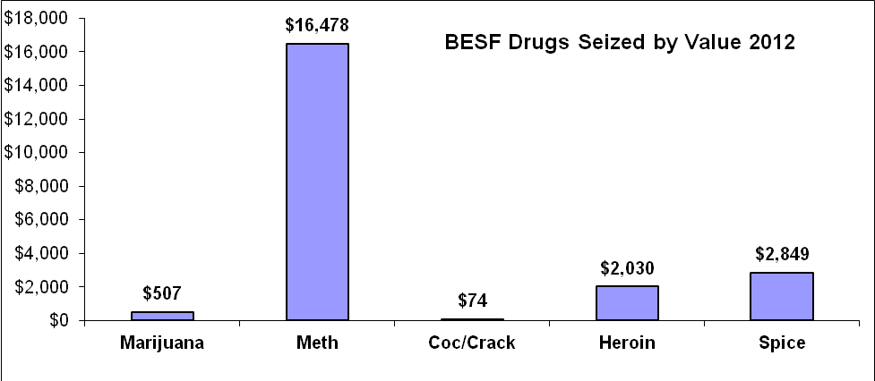

Civil Division

The Sheriff is designated by law to serve civil processes and execute court orders. There is a full-time deputy and full-time secretary assigned to this division. Often, the Patrol or Detective Division will assist in civil process serving to meet demand.

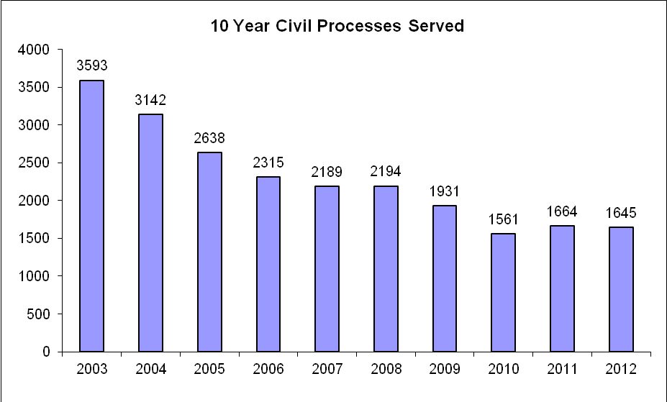

Court Division 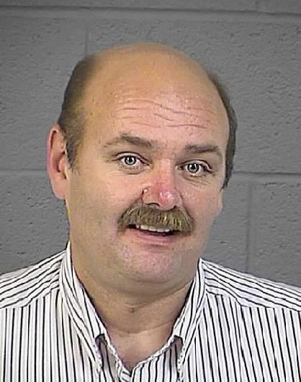

This division is supervised by Sgt. Doug Spencer.

The Sheriff is required, by law, to provide services to the District Court, Juvenile Court and the new Box Elder Justice Court building. This includes Bailiff duties and building security.

A Bailiff of the court is tasked with the safety of the judge and court staff and to maintain order in the courtroom.

The Security aspect includes monitoring court buildings and areas through a control center, magnetometers, security entry points and uniformed officers.

District Court Bailiff Hours: 1,739

Justice Court Bailiff Hours: 1,396.5

Total Hours 3,135.5

District Court Security Hours: 6,750

38,269 visitors to the 1st District Court House in 2012.

Patrol Division 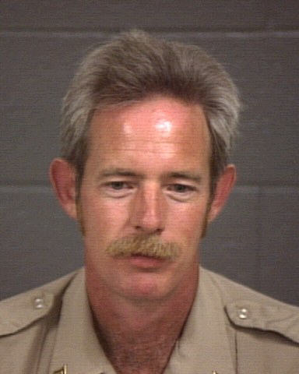 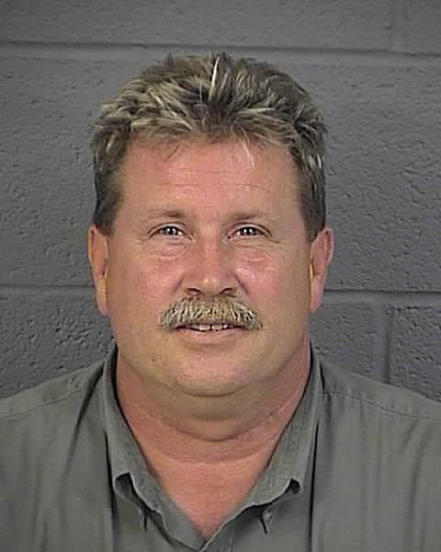 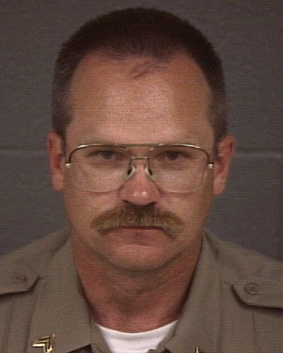
Murphy Berry Summerill

The patrol division is supervised by Sgt. Dave Murphy, Sgt. Steve Berry, and Sgt. James Summerill. There are 15 deputies and 3 Sergeants assigned to cover the county 24 hours a day. Due to the size of the county, deputies are assigned to cover patrol areas during their shifts. This includes the western part of the county.

Community Area Representatives –CAR
In additional to regular patrol duties, deputies are assigned a town or area in the county. They are expected to attend community meetings or functions and have an expertise in that community. To find out what deputy is assigned to your area, please call one of the patrol Sgts. (Sgt. David Murphy 435-734-3826, or Sgt. Steve Berry 734-3885 or Sgt. Jim Summerill 734-3806).

K-9
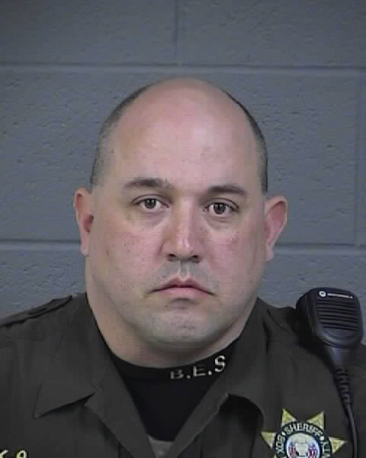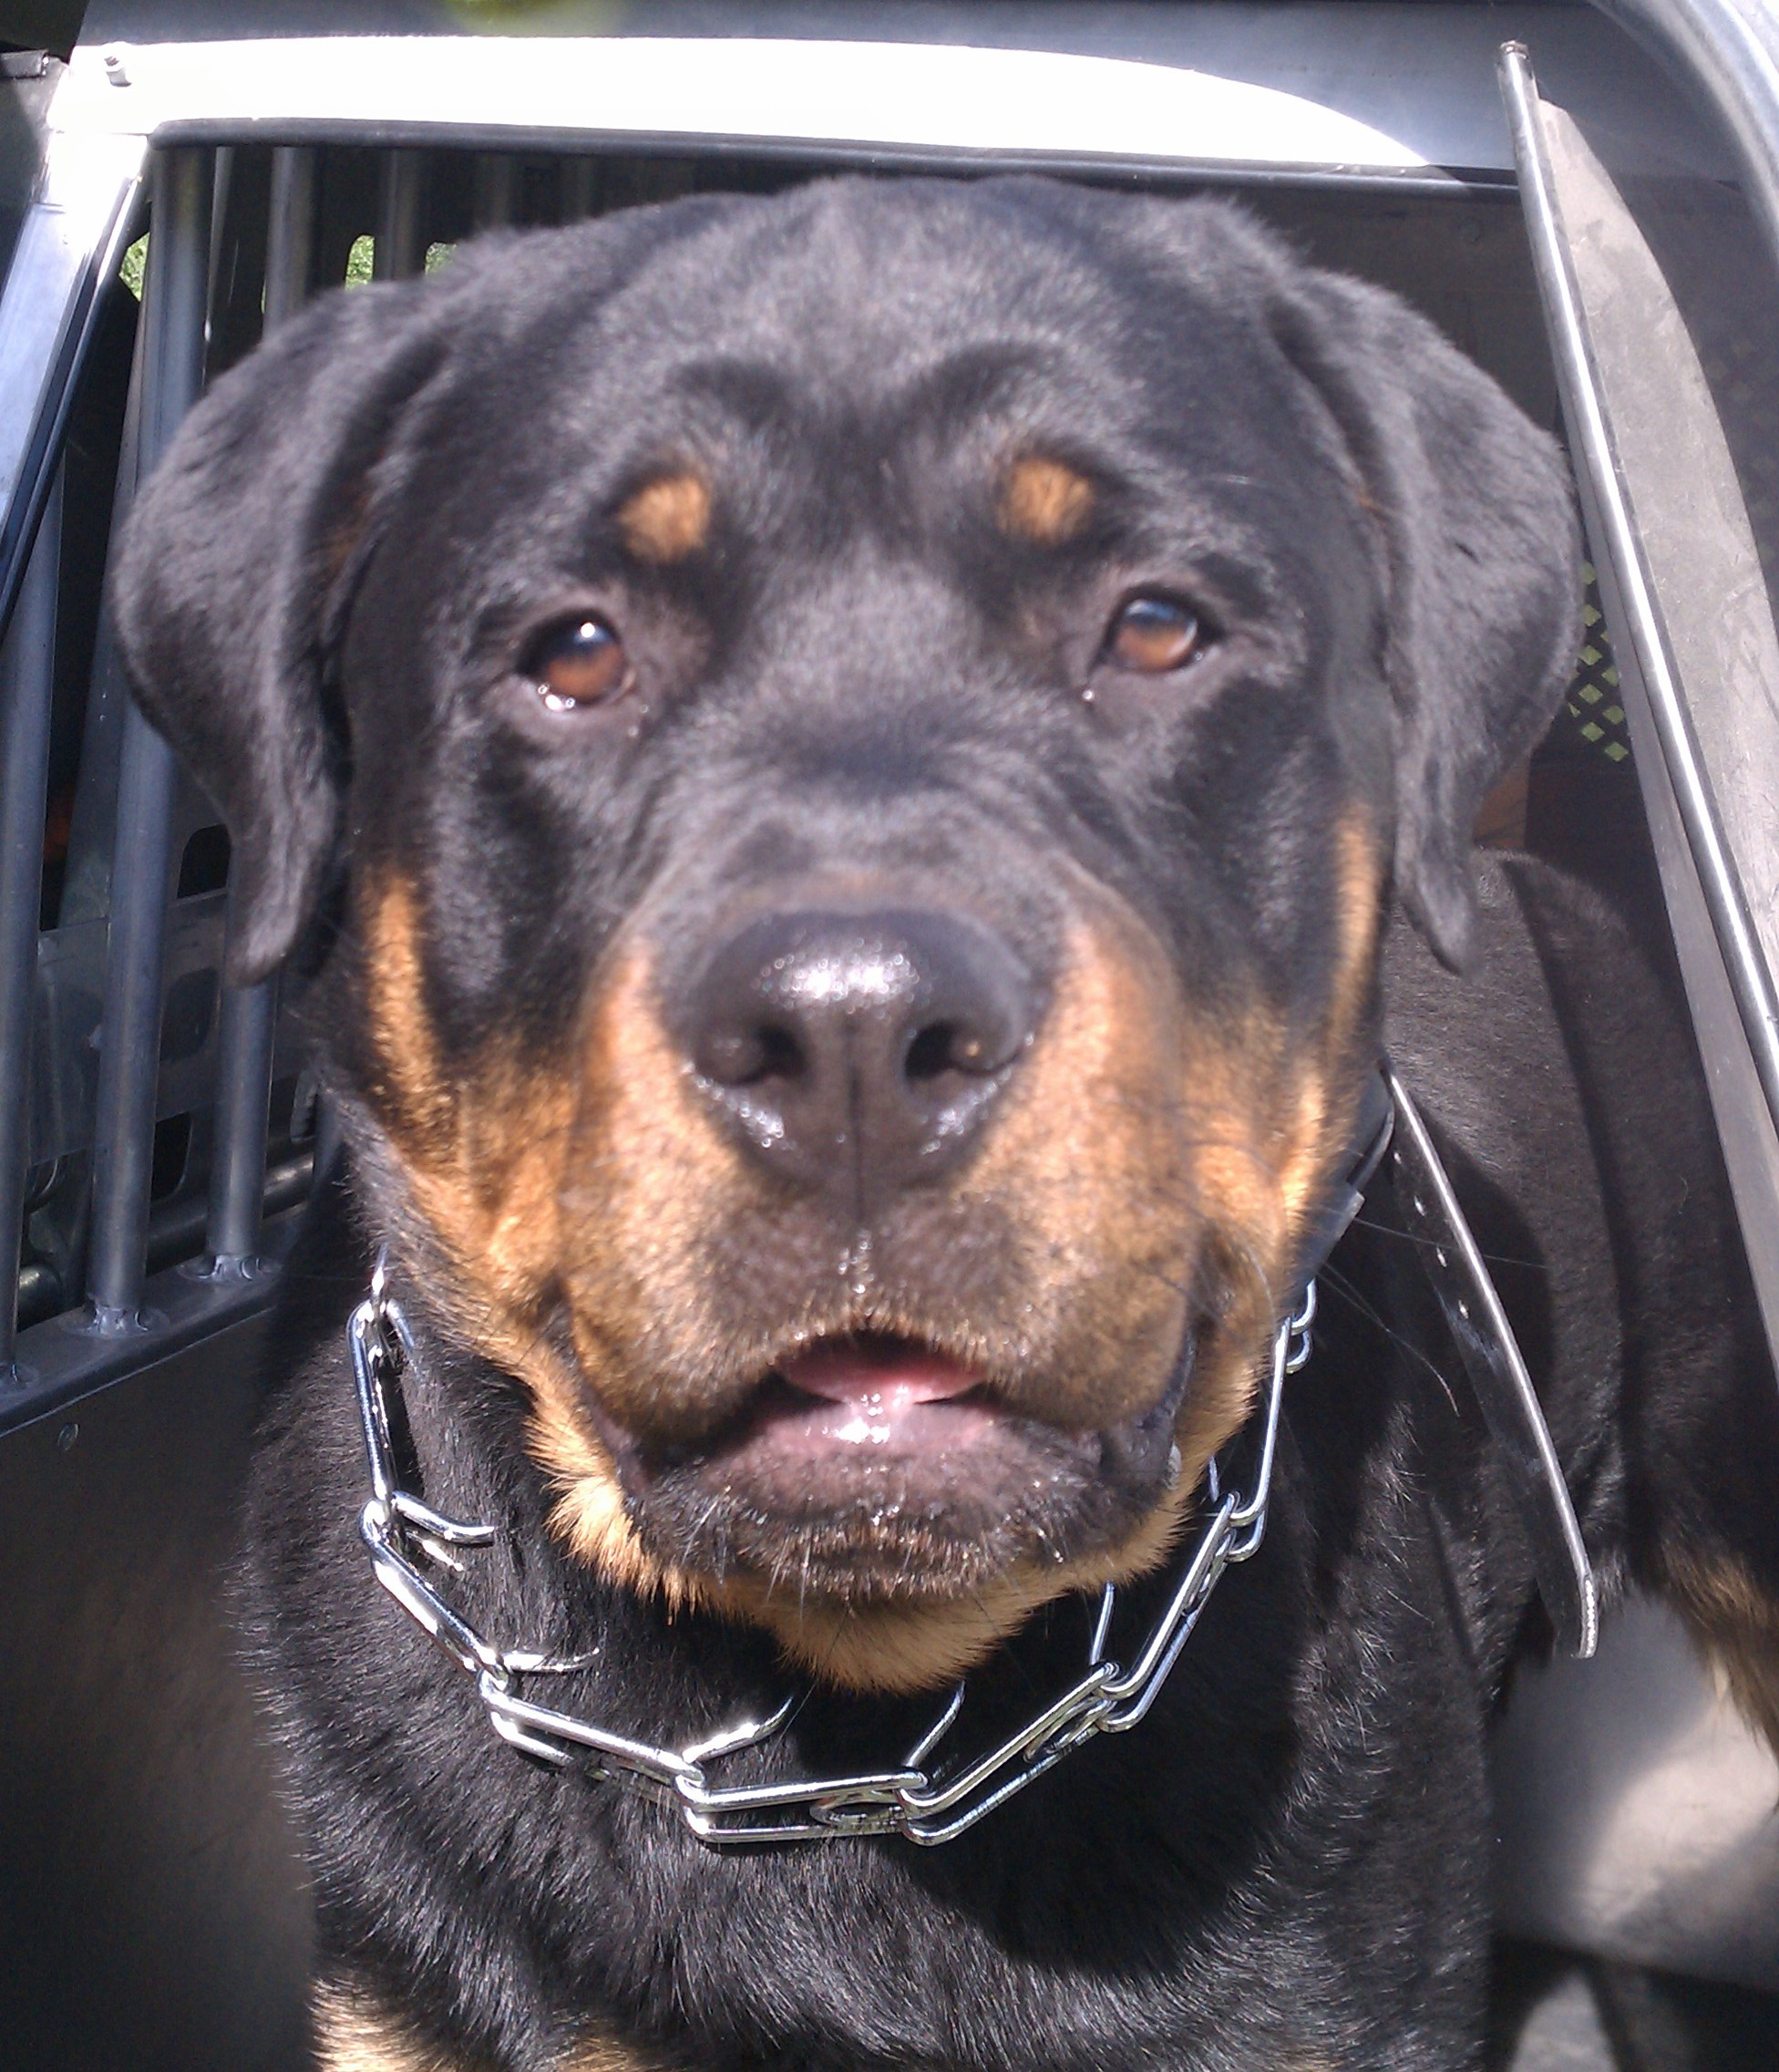
Deputy Yates is an experienced dog handler and previously served three years with K-9 Kosmo. When Kosmo died at the end of 2010, Deputy Yates started training a new Rottweiler puppy, Tonka. Tonka has matured during 2012 and is scheduled to attend Post in 2013 ready to fight crime.

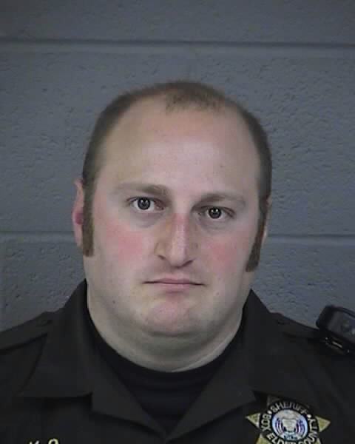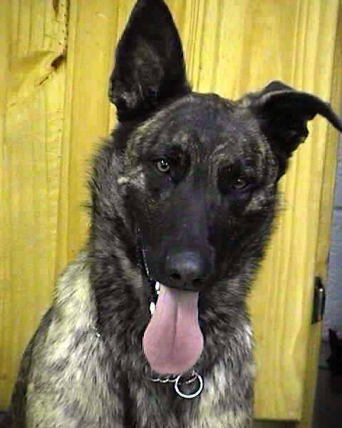
Deputy Ted Bennett was picked as a new K9 handler in 2011. He will be working with K-9 Guri, a Dutch/German Shepherd. They graduated from a 3 month K-9 training and certification at the Police Academy in January 2012.

SWAT/SOG/Negotiations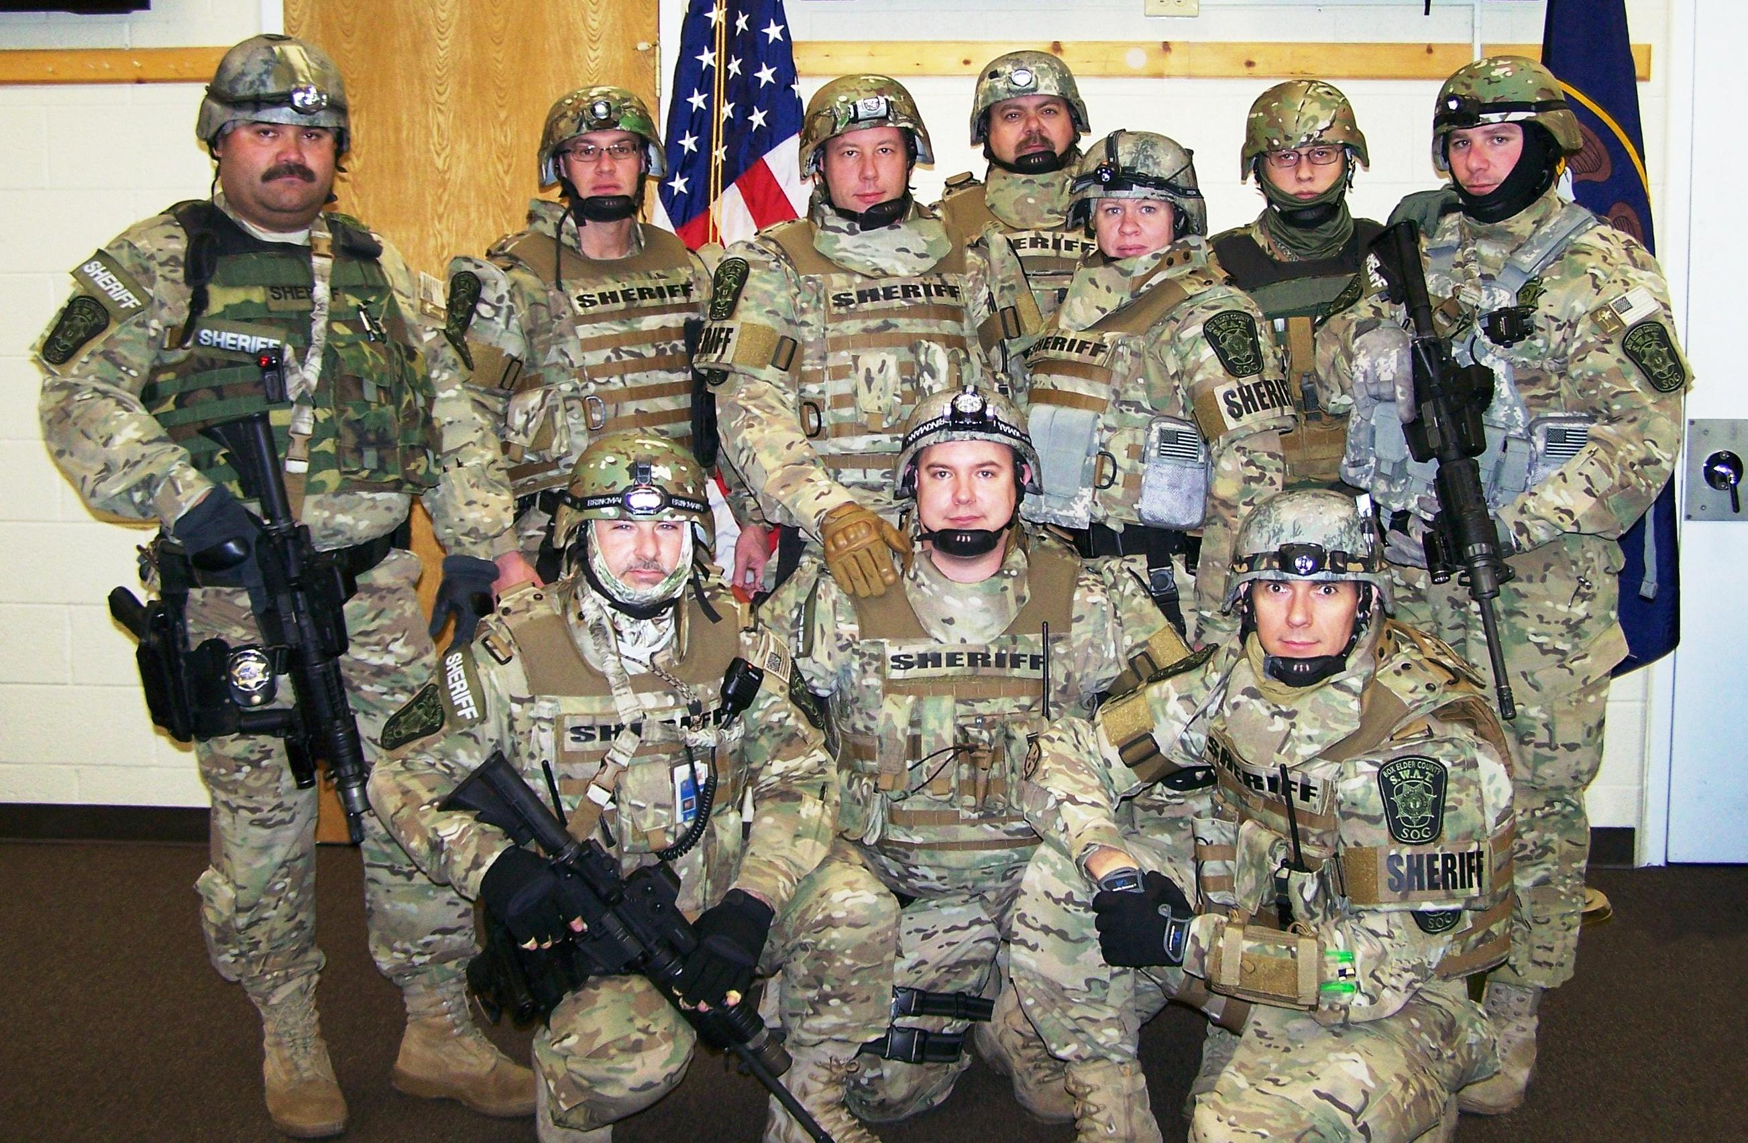
BESO started up a new county team comprised of BESO officers and will respond to SWAT/SOG calls in the areas patrolled by BESO and other areas upon request.
Our Crisis Negotiations Team is comprised of 4 officers who are certified or are currently attending a certification in negotiations and are separate from the SWAT/SOG Team.

Drug Recognition Experts (DRE)
The county has Officers certified as DRE. The Officers are trained to recognize the physical, clinical and neurological signs and symptoms associated with different kinds of drug use. DRE’s are an invaluable asset for drug related DUI’s and other crimes.

2012 Calls for Service by Nature
911 Unknown | 69 |  | Fraud | 50 |  | Recovered Vehicle | 2
Abandoned Vehicle | 22 |  | Gang Problem | 1 |  | Road Debris | 3
Accidental Disc | 2 |  | Gas Leak | 4 |  | Road Rage | 2
Admin Assn | 2 |  | Gas Skip | 5 |  | Runaway Juvenile | 14
Agency Assist | 467 |  | Harassment | 31 |  | Search & Rescue | 6
Aggravated Assault | 4 |  | Health & Safety | 86 |  | Security Check | 5
Alarm | 70 |  | Hit & Run PD | 3 |  | Sex Offense | 18
Alcohol Offense | 15 |  | Illegal Burning | 10 |  | Sheriff Service | 9
Animal Problem | 157 |  | Impound | 11 |  | Simple Assault | 22
Assault by Prisoner | 3 |  | Indecent Expos | 2 |  | Slide Off | 10
Attempt Locate | 5 |  | Industrial Acc | 1 |  | Stab/Gunshot | 6
Burglary | 36 |  | Intoxication | 10 |  | Stalking | 2
Carbon Monoxide | 7 |  | Juvenile Problem | 50 |  | Suicide Attempt/Threat | 13
Child Abuse | 15 |  | K9 | 25 |  | Suspicious | 295
Citizen Assist | 423 |  | Keep The Peace | 11 |  | Tel Harassment | 11
Civil Problem | 48 |  | Littering | 4 |  | Theft | 112
CO Poisoning | 1 |  | Livestock | 96 |  | Theft Automobile | 6
Com Policing | 126 |  | Lost Property | 7 |  | Theft Motorcycle | 1
CRIM MISCHIEF | 1 |  | Mail Offenses | 1 |  | Theft Vehicle | 2
Custodial INT | 26 |  | Medical | 140 |  | Threatening | 35
Death Invest | 13 |  | Mental Problem | 2 |  | Tip | 23
Deliver Message | 1 |  | Misconduct | 1 |  | Tobacco Problem | 8
Disorderly | 8 |  | Missing Person | 14 |  | Traffic Enforcement | 99
Drug Recognition Expert | 11 |  | Motorist Assist | 38 |  | Transport Juvenile | 24
Drugs | 21 |  | Noise Complaint | 32 |  | Transport Prisoner | 33
DUI | 11 |  | Offender Search | 3 |  | Trespassing | 55
Escape Custody | 1 |  | Overdose | 12 |  | Unknown Problem | 7
Escort | 1 |  | Parking Problem | 11 |  | Unsecure Premises | 62
Evading | 1 |  | PD Accident | 92 |  | Utility Problem | 5
Extra Patrol | 365 |  | PI Accident | 26 |  | Vandalism | 31
False Report | 1 |  | Pass Message | 1 |  | Vehicle Burg | 9
Family Fight | 55 |  | Pornography | 1 |  | Vehicle Lockout | 4
Fire | 95 |  | Probation Viol | 1 |  | VIN Inspection | 193
Fishing w/o License | 1 |  | Property Damage | 50 |  | Wanted Person | 92
Fix It Ticket | 7 |  | Prot Order Viol | 17 |  | Watercraft Asst | 2
Follow Up Inv | 11 |  | Prowler | 4 |  | Weapon Offense | 49
Forgery | 1 |  | Psychiatric | 4 |  | Wildlife | 3
Found Child | 1 |  | Rape | 1
Found Property | 18 |  | Reckless Driving | 10

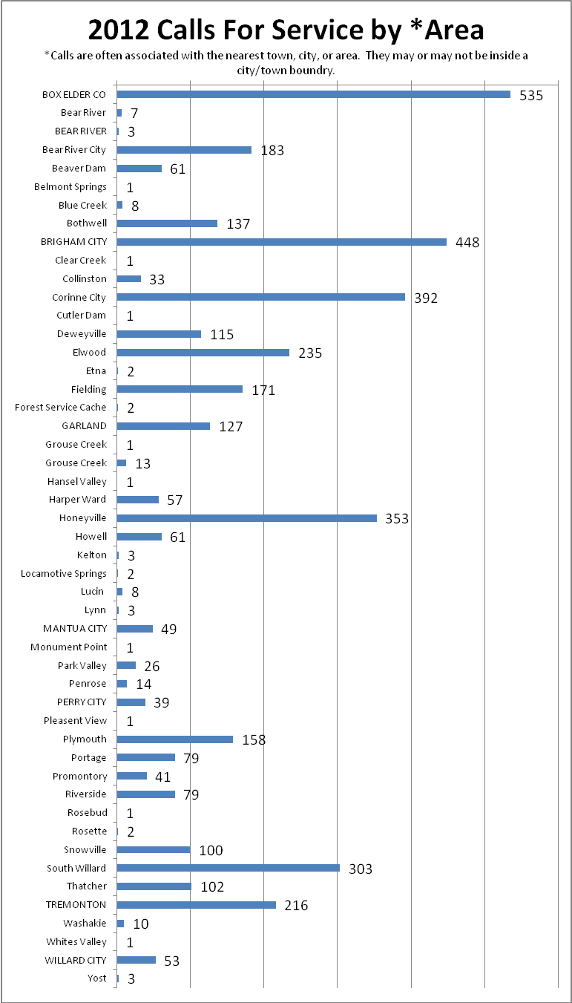
Total 4263

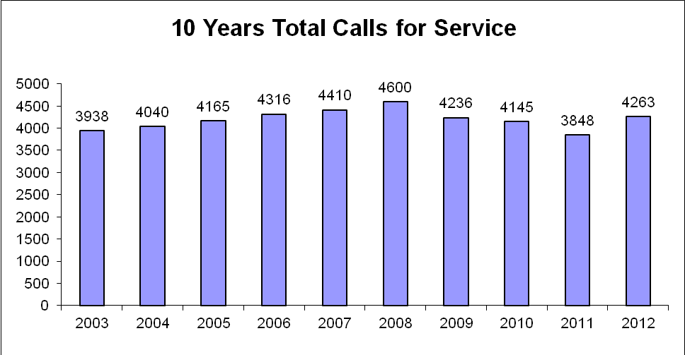

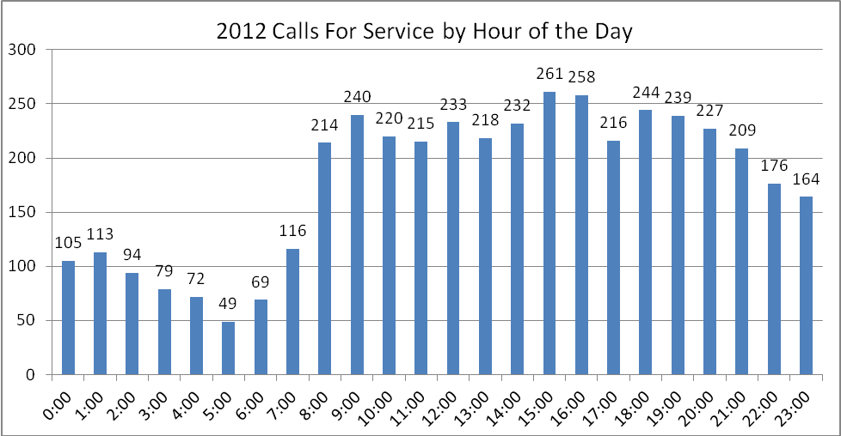

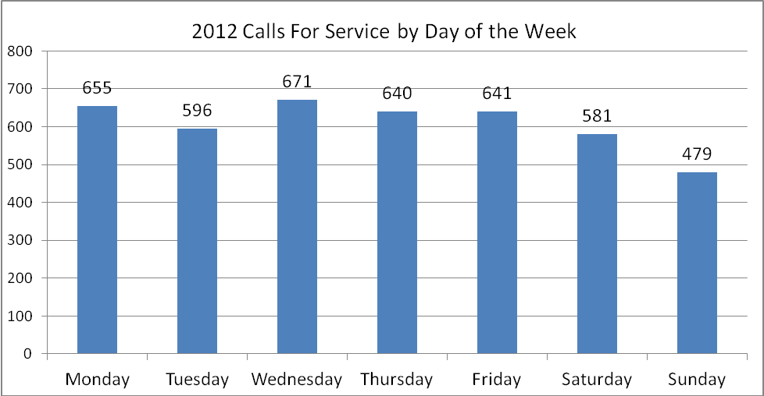

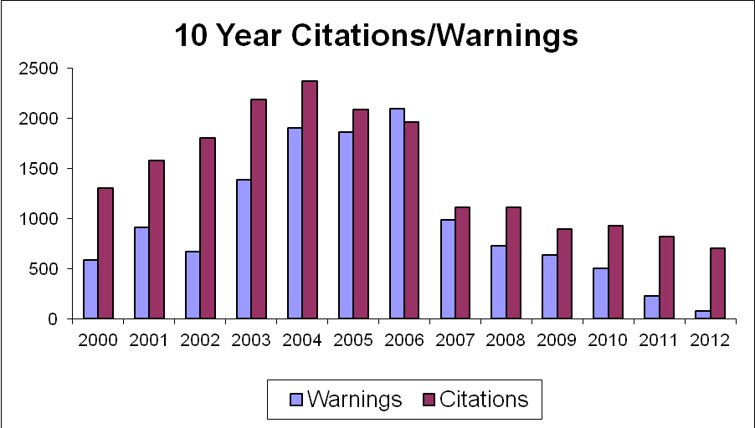

*498 Verbal warnings for traffic violations were also given in 2012.

Speed-Box

At the end of 2009 the Department purchased a device that measures traffic at specific locations. The Speed-Box, as we like to call it, can be placed at any location in the County to measure 4 traffic statistics; how many vehicles passed by, time of day, speed, and direction of travel. From this data we see the true picture of each location’s traffic. This data helps Deputies know how best to conduct speed enforcement.

Corrections Division 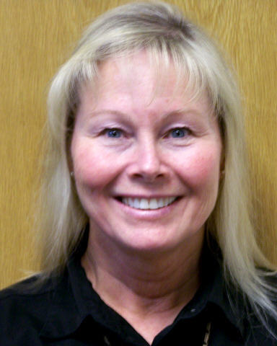

The Corrections division is supervised by Commander Sandy Huthman.

The following is a summary of the year 2012 for the Box Elder County Jail. The Jail consists of several individual divisions providing different services. This includes Corrections Operations, Inmate Services, Visitation, Maintenance, Medical, Transportation, Court Security, Kitchen and SRT(Special Response Team). The following report is a summary of each.
Corrections Staff:
1-Jail Commander
1-Assistant Jail Commander/Sgt
4-Sgts
20-Officers
1-Visitation Officer
1-Work Crew Officer
4-Inmate Services Officers
1-Court Security Sgt
2-Transportation Officers
6-Court Security Officers
Civilian Staff:
1-Maintenance Person
2-Nurses (1-Full time and 1-Part time)
1-MD
5-Kitchen Staff
1-Instructor
Volunteer Staff:
Non-Denominational Church Services
LDS Church Services
Catholic Church Services
Assembly of God
GED
Bible Study
Parenting
AA
Relief Society

Corrections Operations:
In 2012 we added another Sgt to ensure supervision during the year long deployment of one of our Sgts.
We had our jail inspection in July for both the Sheriff’s Association and the State Department of Corrections. We are 100% compliant with the standards.
In 2012 the jail training hours totaled 4379.50. This is attained through outside agency and in-house training put on by Corrections staff. It encourages all Officers to submit ideas and suggestions for improvement of processes within the jail. This also enhances the safety of the Officers, Civilians and the Inmates, and the security of the jail and the overall knowledge that each Officer develops throughout their career. It is my goal to find any training or tools that would make the jail more productive and as liability free as possible.

Inmate Services
Work Crew:
We only have 1 Inmate Work Crew with 1-Officer and minimum of 2 inmates.
Our Work Crew grew all the flowers for the Sheriff’s office. Also, the garden was very profitable producing approximately 7000 lbs of vegetables (potatoes, carrots, tomatoes squashes, etc). At the end of the 2012 growing season, the work crew doubled the size of the green house. I’m excited to see what they are able to produce this year. This is an invaluable resource for the jail, and learning experience for the inmates.
Work Crew County hours:
Fair Time: 240 hrs
Fairgrounds: 256 hrs
Voting Booths: 100 hrs
Road Shed: 80 hrs
Misc County: 40 hrs

Visitation:
Our current Visitation Officer tested and was selected for a Patrol position. We will be moving an Officer from a floor position to work out in Visitation. We will hire a replacement for that officer.

Maintenance:
Maintenance has been very busy this year replacing worn out items/equipment in the jail. One of the boilers was replaced, and replaced parts on roof top units. New 360 degree cameras in 5 dorms which allows for better observation of the inmates and better safety and security of the jail.

Medical:
We continue to pay Medicaid amounts for our inmate medical bills. We do bill the amount we pay on the medical to the inmate. A rough estimate on the overall payment of a medical bill is about 25% of normal costs.

Transportation:
We received our new transport van and had an insert put in the back of it to be able to ensure more secure transportation of males and females.

Kitchen:
There were no major issues in the kitchen for 2012. The kitchen still has received excellent inspections from the health department due to the tremendous job that the kitchen staff does ensuring that the sanitary condition of the kitchen is maintained. There were 131,463 meals served by the kitchen this year. The average cost per meal was $2.06.

SRT (Special Response Team, This is the Jails equivalent to SWAT):
We have 8 members on the SRT team. The Officers have been instructed to call out SRT rather than handling any inmate that may be unruly to prevent any injuries to the Officers and/or the Inmates. SRT is specifically trained to manage these types of situations.
There were 5 SRT callouts for 2012 and 2 resulted in transportation to the ER.

Areas of income:
State Inmate Housing:
2011 Total Inmates-360 Total Inmate Days-9561 / Amount Received- $430,245.00 (@45.00 per day per inmate)
2012 Total Inmates-327 Total Inmate Days-8761 / Amount Received- $394,245.00 (@45.00 per day per inmate)

Condition of Probation and Parole:
2011 Total Inmates-272 Total Inmate Days-5313 / Amount received- $143,982.30 (@27.10 per day per inmate)
2012 Total Inmates-280 Total Inmate Days-5544 / Amount received- $150,242.40 (@27.10 per day per inmate)

Work Release:
2011 57-Work Release Inmates / Amount Received- $13,473.33
2012 31-Work Release Inmates / Amount Received- $8,769.38

Pay for Stay:
2011- $18,176.57
2012- $13,244.00

Day Reporting:
2011- $795.00
2012- $485.00

Total of all monies brought in by the jail and turned into the county for 2012: $678,709.69

Housing Costs:
2011 Fiscal Activity: $3,399,509.59 Total Inmate Days: 45,479 Cost per day: $74.74
With Court Security/Transport Fiscal Activity: $576,515.96 Cost per day: $87.42
2012 Fiscal Activity: $3,368,386.87 Total Inmate Days: 41,899 Cost per day: $80.39
With court security/Transport Fiscal Activity: $678,473.33 Cost per day: $96.58

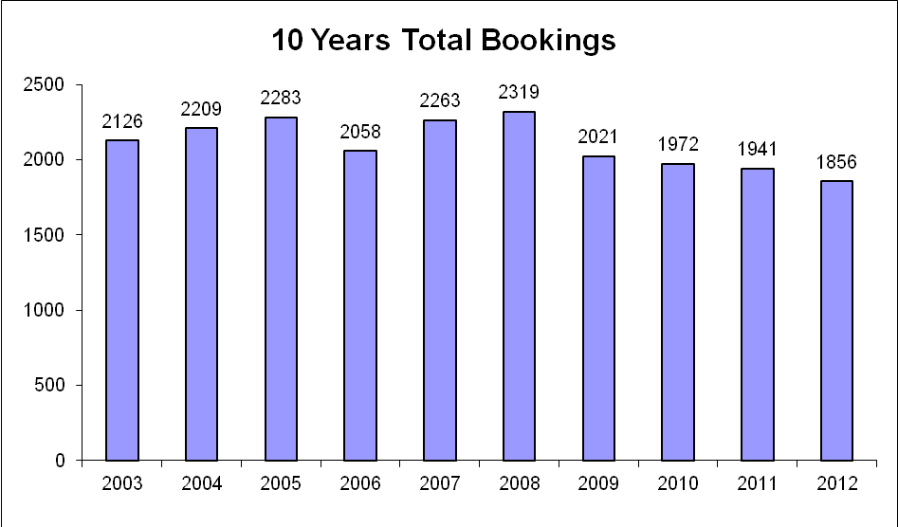

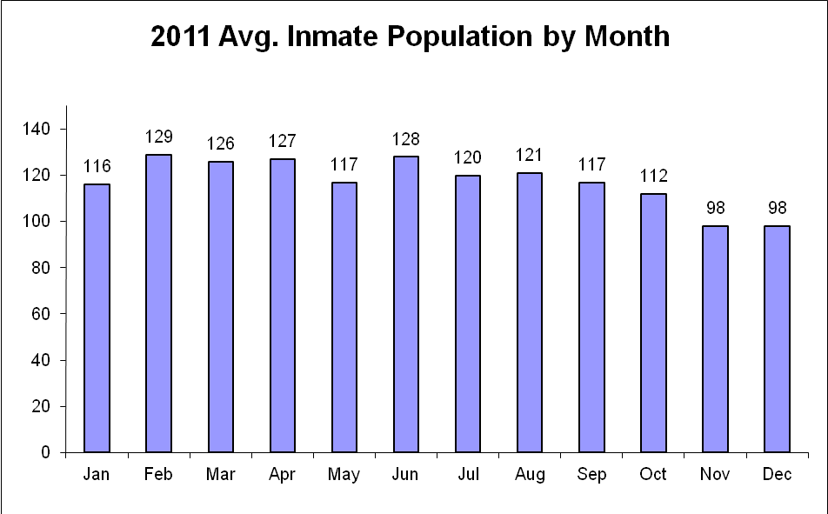

ITS 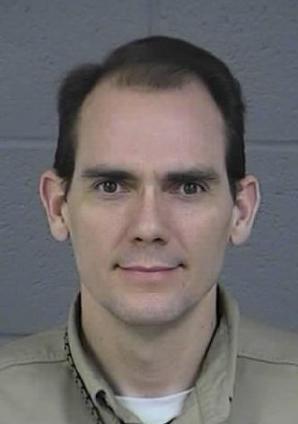
Corrections Officer Russell Roberts is responsible for the maintenance, repair, upgrades and replacement of computers, laptops and servers at the Sheriff’s Office.

Communications/Dispatch

Box Elder Communications Center (BECC) is managed by the State of Utah thru Lesa Wilson, manager.

Emergency Management
Emergency Management is the process of mitigating, planning, responding and recovering from natural disasters/terrorism/haz-mat. The Chief Deputy and the Sheriff have this assignment.
Emergency Medical Services falls under the Sheriff who oversees 12 Emergency Medical technicians and 2 ambulances in Park Valley.

Buildings and Grounds
A Dave Sangberg, a full-time civilian employee is responsible for the care, repair, maintenance and upkeep at the jail, offices, West cabins and storage buildings.

Fire Marshall 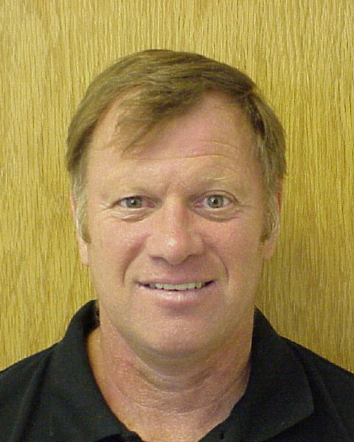

Greg Martz is the Box Elder County Fire Marshall.

Wildland fires in the un-incorporated areas of the county are a Sheriff’s responsibility by law. That’s why the Fire Marshall works out of the Sheriff’s Office. There is one full-time Fire Marshall and one part-time secretary. Part-time marshals are hired during fire season. Contracts with local fire departments give the county the manpower needed to fight Wildland fires. There is state and federal reimbursement for fighting fires on their property.

2012
Wild Fires responded to | 79
Acres burned | 13,754.02
Cost | $94,671

Volunteer Organizations

Box Elder Sheriff Search and Rescue
With about 30 active members, this all volunteer group will leave their “real” jobs at a moment’s notice to conduct rescue or recovery operations. They are equipped with 4 wheel drive trucks, ATV’s, UTV’s, snowmobiles, snow-cat, light plant truck and a command center. They conduct approximately twenty operations per year. They also provide security at the County Fair.

Box Elder Sheriff Scuba Team
This all volunteer group specializes in water rescue and recovery. 20 members are certified rescue divers and 20 are support staff. They are equipped with a pontoon boat, zodiac, 2 airboats and a command center. They assist at the County Fair and operate on funds raised by selling the famous “Scuba Burger” at Peach Days.

Box Elder Sheriff’s Horse Posse
The 50+ person volunteer group is available for extended searches and also dazzles crowds at the County Fair with a horsemanship display.

